

# Career Action Plan Workbook

**[To edit, please download and save as a Microsoft Word document to your computer]**

**This workbook will help you build a Career Action Plan, outlining the necessary steps to enhance the knowledge, skills, and experience required to achieve your career goal. Refer to your completed** [**Gap Analysis Worksheet**](https://careers.wgu.edu/resources/gap-analysis-worksheet/) **to complete the activities below.**

*[To edit, please download and save as a Microsoft Word document to your computer].*

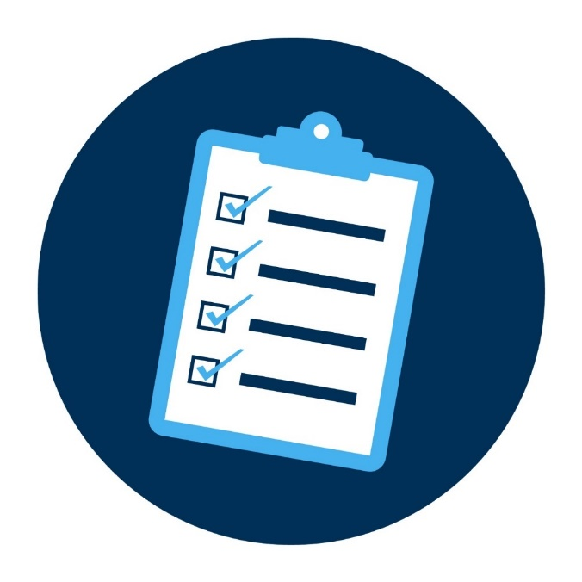

**My SMART Career Goal**

**Type your SMART Career Goal in the box below to remember what you are working toward.**

You may have created this goal during your Orientation with WGU. If you still need to create a SMART Career Goal, follow the steps outlined on this [page](https://careers.wgu.edu/channels/identify-your-career-goal/).

# Set Short-Term Goals

**Instructions:** follow the instructions below to create a short-term goal for each skill and experience gap from your [Gap Analysis Worksheet](https://careers.wgu.edu/resources/gap-analysis-worksheet/).

* Review the *“*Action to Close Gap” column on your Gap Analysis Worksheet. Write a short-term goal for each of your actions in the categories below that are relevant to your needs. See examples on Page 3.
* Set a date by which you’d like to complete each goal. It’s okay if you need to adjust this date along the way.
* When possible, break down your short-term goals into smaller action steps to hold yourself accountable to tasks that will help you reach goals. See examples on Page 3.

## Education & Training

Upskill in your target field by [earning your degree](https://www.wgu.edu/online-degree-programs.html), completing certifications, or taking [professional development courses](https://careers.wgu.edu/channels/professional-development/)*.*

|  |  |  |
| --- | --- | --- |
|  | Goals & Action Steps | Complete By: |
|  | **Goal 1: Complete MSDA program** | Nov 1, 2025 |
|  | *Action Step 1: devote 40 hours a week to coursework* |  |
|  | *Action Step 2:* |  |
|  | **Goal 2: Explore Kaggle platform** | Oct 1, 2025 |
|  | *Action Step 1: devote 5 hours a week to exploring datasets* |  |
|  | *Action Step 2:* |  |
|  | **Goal 3: Data Visualization in Tableau (edX – free?)** | Nov 1, 2025 |
|  | *Action Step 1: (if free) devote 5 hours a week to competing edX course* |  |
|  | *Action Step 2:* |  |

## Experiential Learning (Learning By Doing)

Gain hands-on experience in your target career field via [micro-internship](https://info.parkerdewey.com/wgu/students)s, [virtual simulations](https://www.theforage.com/landing/Western%20Governors%20University/kcXtCdj3c92qAfw3f/Experience%20Without%20Boundaries%20for%20WGU%20Students), [internships, volunteering,](https://careers.wgu.edu/resources/wgu-internship-experiential-learning-guide-pdf/) clinical work, [on-the-job training](https://careers.wgu.edu/resources/explore-current-work-opportunities-guide/), apprenticeships, entry-level work, self-employment, or independent projects.

|  |  |  |
| --- | --- | --- |
|  | Goals & Action Steps | Complete By: |
|  | **Goal 1: Build a database for portfolio project** |  |
|  | *Action Step 1: choose a topic for portfolio project* |  |
|  | *Action Step 2: collect data* |  |
|  | **Goal 2: Explore part-time data analysis projects/roles in Indianapolis or remote** | July 1, 2025 |
|  | *Action Step 1: devote 30 minutes a day to LinkedIn/job boards* |  |
|  | *Action Step 2:* |  |
|  | **Goal 3:** |  |
|  | *Action Step 1:* |  |
|  | *Action Step 2:* |  |

## Networking

Build and strengthen your [professional network](https://careers.wgu.edu/channels/expand-your-professional-network/) by reaching out to existing contacts, making new connections on LinkedIn, joining professional associations or student groups, attending employer events on Handshake, etc.

Networking can unlock new opportunities, mentorship, and career insights. Building relationships with professionals in your desired career path deepens your understanding of expectations for success. These connections can also help you learn how to present yourself as a strong candidate for your next career step.

* **Create *at least* 1 short-term networking goal that will help you get closer to your career goal.**

|  |  |  |
| --- | --- | --- |
|  | Goals & Action Steps | Complete By: |
|  | **Goal 1: Make new data analysis/data science connections on LinkedIn** | Oct 1, 2025 |
|  | *Action Step 1: get LinkedIn premium from Liliana* |  |
|  | *Action Step 2: use reach out template to connect & message connections* |  |
|  | **Goal 2:** |  |
|  | *Action Step 1:* |  |
|  | *Action Step 2:* |  |
|  | **Goal 3:** |  |
|  | *Action Step 1:* |  |
|  | *Action Step 2:* |  |

## Career Management

Prepare for your career goal by updating your [résumé](https://careers.wgu.edu/channels/resumes/) and [cover letter](https://careers.wgu.edu/channels/cover-letters/); building a [portfolio](https://careers.wgu.edu/channels/portfolios/) to showcase your work, refining your [personal brand](https://careers.wgu.edu/channels/personal-branding/), honing your [interview skills](https://careers.wgu.edu/channels/job-interview-prep/), researching employers and [employment opportunities](https://careers.wgu.edu/channels/find-a-job/), etc.

Successful career management will help ensure you put your best foot forward, maximizing your chances of securing opportunities while positioning yourself as a standout candidate in the competitive job market.

* **Create *at least* 1 short-term career management goal that will help you prepare for your career goal.**

|  |  |  |
| --- | --- | --- |
|  | **Goals & Action Steps** | **Complete By:** |
|  | **Goal 1: Update resume / create cover letter template** | July 1, 2025 |
|  | *Action Step 1: Tailor resume to data analytics using past Zazzle experience* |  |
|  | *Action Step 2: Use the AI tool to evaluate changes* |  |
|  | **Goal 2: Interview prep / storytelling given my career change journey** | July 1, 2025 |
|  | *Action Step 1: Use AI to help build the storytelling script* |  |
|  | *Action Step 2: Research data analytics/data science interview questions* |  |
|  | **Goal 3:** |  |
|  | *Action Step 1:* |  |
|  | *Action Step 2:* |  |

## Example Short-Term Goals & Action Steps

The examples below represent various career stages, pathways, and degree types.

**Education & Training**

|  |  |
| --- | --- |
|  | **Complete By:** |
| **Goal:** Pass the CompTIA Security+ exam within the next 3 months to boost my skillsets in network security, threat identification, and security fundamentals. | Dec 15, 20xx |
| **Action Step:** Develop a study plan with designated time slots for reviewing study materials each week. | Sept 17, 20xx |
| **Goal:** Complete at least 1 online professional development course for Moodle and Canvas in the next month to familiarize myself with the LMSs required for the roles I’m seeking. | Oct 2, 20xx |
| **Action Step:** Research online course options, considering factors like content, duration, and user reviews. | Aug 31, 20xx |

**Experiential Learning (Learning By Doing)**

|  |  |
| --- | --- |
| **Goal:** Complete 2 software engineering work simulations (3-6 hours each) on Forage within the next 2 months to obtain more programming, front-end, and back-end development skills. | Nov 6, 20xx |
| **Action Step:** Schedule time slots in my calendar for the next 2 months, allocating 3-6 hours for each simulation. | Sept 8, 20xx |
| **Goal:** Meet with my manager in the next month to discuss the possibility of taking on additional responsibilities or tasks related to project management in my current company. | Oct 9, 20xx |
| **Action Step:** Draft an email to my manager requesting a meeting to discuss my goals. | Aug 12, 20xx |

**Networking**

|  |  |
| --- | --- |
| **Goal:** Find at least 2 virtual or in-person healthcare employer events or professional development workshops to attend in the next 4 months to meet more people in the industry. | May 21, 20xx |
| **Action Step:** Set a phone reminder to search and register for employer/industry events on [Handshake](https://wgu.joinhandshake.com/stu/events?collection=ALL&eventFormat=HYBRID&sort=RELEVANCE&date=ALL) weekly. | Jan 21, 20xx |
| **Goal:** Connect with at least 5 WGU alumni who studied instructional design on LinkedIn and review their profiles to learn more about common qualifications in the next 3 weeks. | Mar 8, 20xx |
| **Action Step:** Use the [LinkedIn Alumni Tool](https://westerngovernorsuniversity.sharepoint.com/:b:/s/Career&ProfessionalDevelopment/EXcHKGc3qulHjIgCvn9ZcvwBCsjZLUxrzLyFmybIM0OG7A) to find WGU alumni who studied ed tech/instructional design. | Feb 19, 20xx |

**Career Management**

|  |  |
| --- | --- |
| **Goal:** Finish my Demonstration Teaching résumé for my professional portfolio and email it to WGU’s Career and Professional Development Team for review within the next 2 weeks. | Sept 18, 20xx |
| **Action Step:** Download the [teacher résumé template](https://careers.wgu.edu/resources/school-of-education/) from CPD to build my résumé. | Sept 4, 20xx |
| **Goal:** Research potential employment opportunities and employers in the nursing field for at least 2 hours per week over the next month. | Jun 2, 20xx |
| **Action Step:** Create a list of job boards and websites to use for research (e.g., Nurse.com, local hospital websites). | May 2, 20xx |

# Strengthen Your Plan

**Congratulations on developing your career plan!**

This plan marks an important step in your professional journey, outlining a clear path to achieving your SMART Career Goal. As you continue to refine your strategy, consider the following prompts to strengthen your plan and stay committed to your objectives.

## Revisit & Revise

Remember to regularly revisit your plan to celebrate your wins and check off your progress! Returning to your plan allows you to make revisions, ensuring it still aligns with your SMART career goal and life circumstances.

* **Specify how often you will revisit your plan to check off your progress and make adjustments as needed.**

I commit to revisiting my career plan **______________________**

(e.g., 1x/month; bimonthly; every other week)

## Barriers & Supports

Despite careful planning, unexpected challenges may arise while pursuing your goal, such as lack of support, familial care, financial struggles, personal challenges, etc. If you prepare for these obstacles, it will be easier to overcome them.

* **Describe potential barriers to achieving your career goal and identify a support strategy for each one.**

|  |  |
| --- | --- |
| **Possible Barriers** | **Support Strategies** |
|  |  |
|  |  |
|  |  |

## Advocates & Accountability Partner

Seeking guidance and encouragement from people you trust will help you stay on track with your plan.

* **Identify your advocates:** Who can provide support as you work on completing your plan?
* **Identify your accountability partner:** Who can you share this plan with and regularly discuss progress?

(e.g., WGU Career Services, program mentor, colleagues, family/friends, WGU alumni, industry professionals, direct supervisor, etc.)